**ECE3410 Lab 6**

Sterling LaBarbera

14096504

spl2q2@mail.missouri.edu

**Objective**

The objective of this lab was to study the functions of a basic OPAMP integrator circuit. We designed the value of the feedback resistor based on the input frequency and feedback capacitance. The circuit was expected to produce an integration of the input, but out of inverted since it is connected to the inverting terminal.

**Description**

I first calculated the value of the feedback resistor using the equations T=RfCf and T=1/f. F = 100kHz, giving a value of 100kOhm for Rf as the given value for Cf was 100pF. I used an LM741 OPAMP for this integrator. I connected bias Voltages of 15V and -15V to the OPAMP. The input voltage source was connected to the inverting terminal of the OPAMP through a small input resistor of 1kOhm. The non-inverting terminal was grounded. The Feedback resistor and capacitor were in parallel and connected between the inverting terminal and the output of the OPAMP.

**Circuit Diagrams**

**Sine Wave Circuit**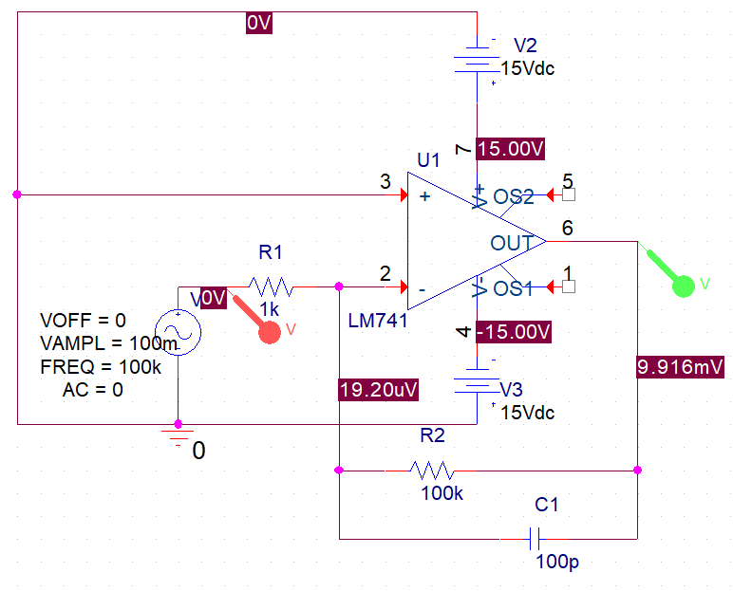

**Square Wave Circuit**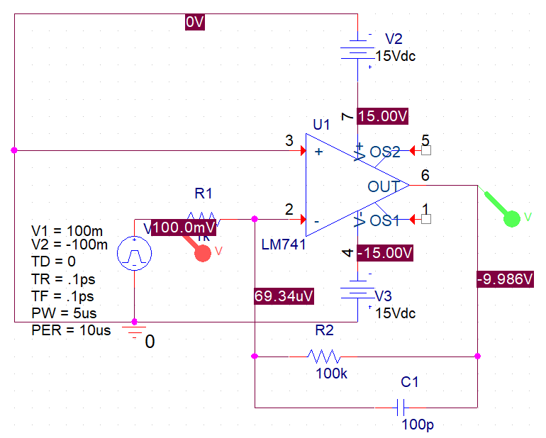

**Triangle Wave Circuit**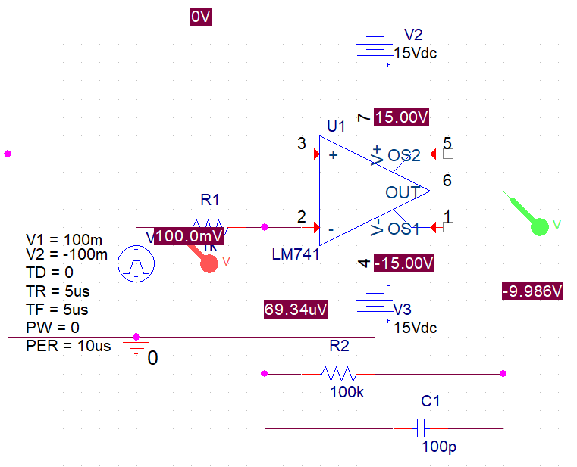

**Process**

* Find the resistor Value for Rf based on the given input frequency.
* Simulate Circuit in PSpice
* Find DC voltages and vo.
* Simulate the AC output and calculate the overall gain.
* Construct the circuit on breadboard.
* Find the DC values for the real circuit using the multimeter.
* Find the output voltages using the Oscilloscope.
* Compute the actual gain.
* Compare with simulation.

**Table of Measurements**

**PSpice Data**

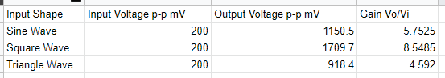

**Breadboard Data**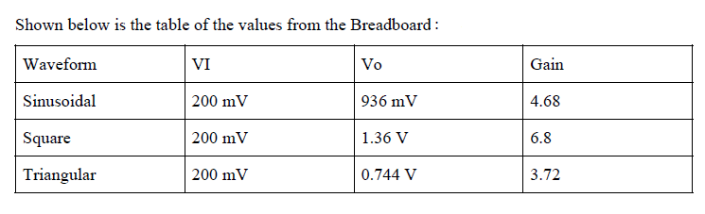

**Characteristics and Plots**

**Sinusoidal Input**

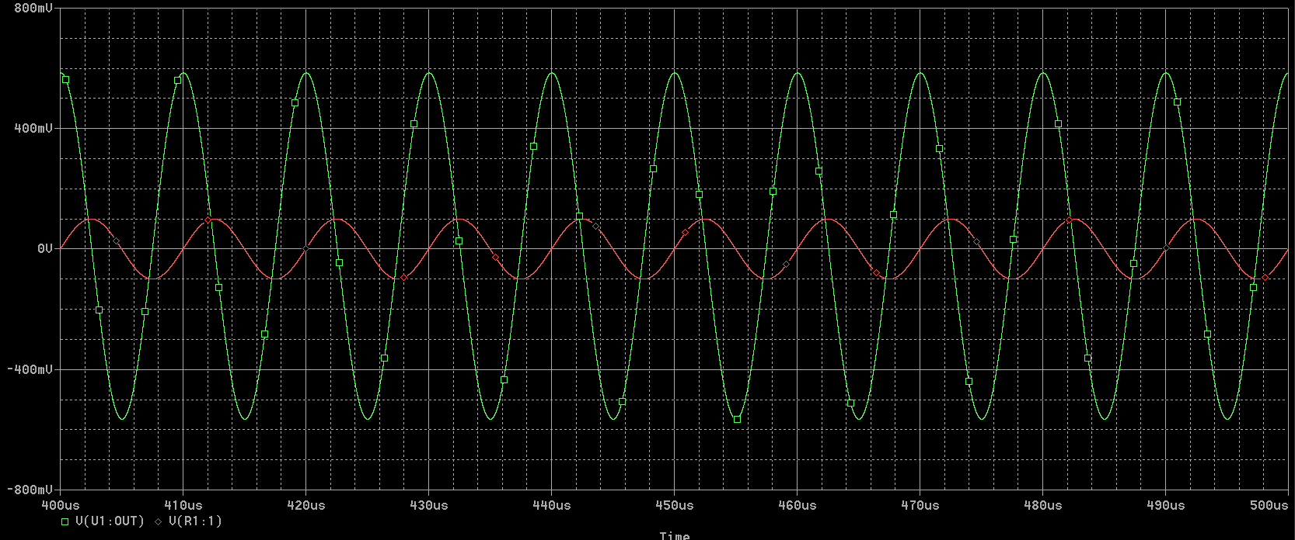

**Square Input**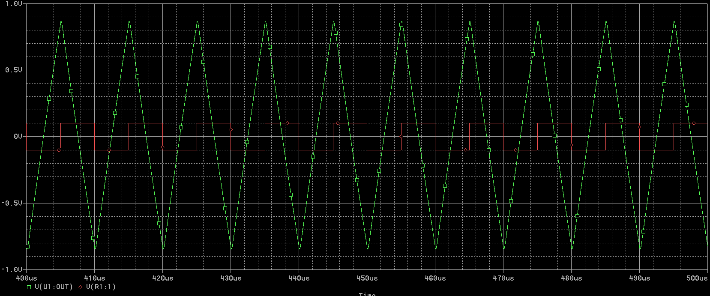

**Triangle Input**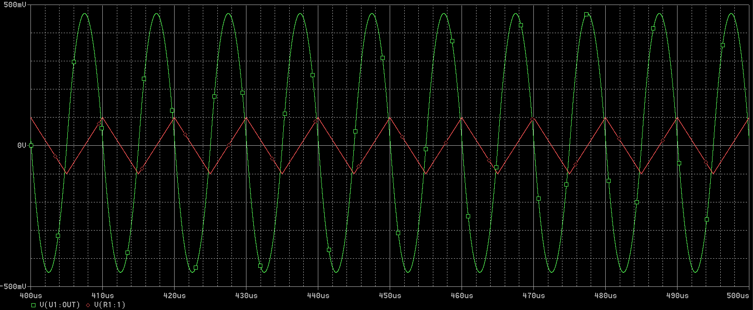

**Breadboard Result**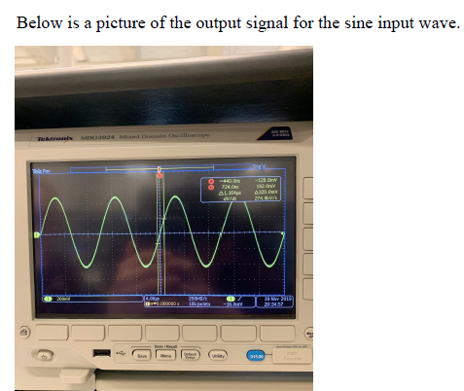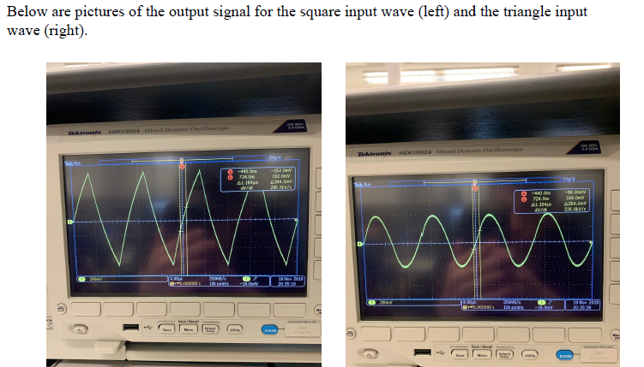

**Explanation of Plots and Results**

By visual inspection, the green output waves in the simulation are integrations of the inputs, but 180 degrees out of phase with the input since the inputs are connected to the inverting terminal of the OPAMP. The time window is 400-500us to minimize the transient response of the circuit. The outputs from the real circuit were the same shape as the simulation. The difference in gain between each input was similar as well, but the total gain was significantly lower in all the real outputs. This is likely related to variations in the feedback resistor and capacitor.

**Summary**

In this lab, we studied an OPAMP integrator circuit with a 100kHz input signal of various shapes. We determined that the Square wave integration has the highest peak to peak voltage amplification, as it outputs a triangle wave, which produces a sharp peak. As expected, the inverting terminal produced an 180 degree out of phase output signal.